

Employee Code

(For Unexempted / Exempted Establishment)

NOMINATION AND DECLARATION FORM

(Declaration and Nomination Form under the Employees' Provident Funds and Employees' Pension Scheme)

(Paragraphs 33 & 61 (1) of the Employees' Provident Funds Scheme, 1952 and paragraph 18 of the Employees' Pension Scheme, 1995)

| 1 | Name (in Block Letters) | :ANUSHKA SRIVASTAVA |
| --- | --- | --- |
| 2 | Father's/Husband's Name | : CHANDRA SHEKHAR |
| 3 | Date of birth | :20-09-1999 |
| 4 | Sex | : FEMALE |
| 5 | Marital Status | :UNMARRIED |
| 6 | Account No. *(PF/EPS Number)* | : |
| 7 | Address *(Residential)* Permanent | :RADHE VIHAR COLONY BANGALA BAZA BIJNOR ROAD NEAR BBAU, LUCKNOW (226025) |
|  | Temporary | :RADHE VIHAR COLONY BANGALA BAZA BIJNOR ROAD NEAR BBAU, LUCKNOW (226025) |
| 8 | Date of Joining - EPF/EPS | :7-02-2022 |

# PART A (EPF) #

I hereby nominate the person(s)/cancel the nomination made by me previously and nominate, the person(s) mentioned below to receive the amount standing to my credit in the Employees' Provident Fund, in the event of my death:

| Name and Address of the nominee/ nominees | Nominee's relationship with the member | Date of Birth | Total amount or share of accumulations in Provident Fund to be paid to each nominee (%) | *If the nominee is a minor, name and relationship and address of the guardian who may receive the amount during the minority of nominee* |
| --- | --- | --- | --- | --- |
| (1) | (2) | (3) | (4) | (5) |
| SUSHMA SRIVASTAVA | MOTHER | 22-07-1972 | 60% |  |
| CHANDRA SHEKHAR | FATHER | 27-09-1969 | 40% |  |
|  |  |  |  |  |
|  |  |  |  |  |
|  |  |  |  |  |
|  |  |  | **100 %** |  |

1. * Certified that I have no family as defined in para 2(g) of the Employees' Provident Funds Scheme, 1952, and should I acquire a family hereafter, the above nomination should be deemed as cancelled.
2. * Certified that my father/mother is/are dependent upon me.

3. * Strike out whichever is not applicable.

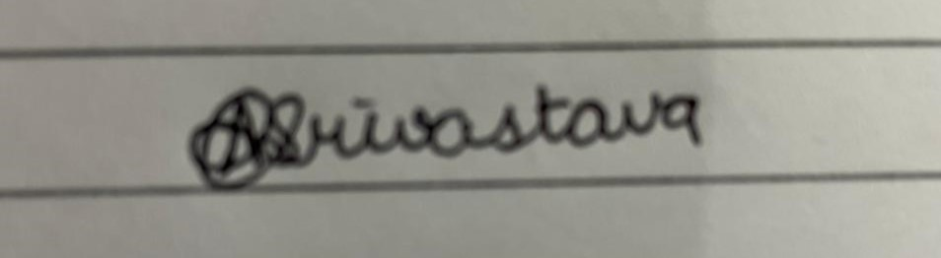

Insert Signature



Signature or thumb impression of the subscriber



Part B (EPS) (Para 18) $

I hereby furnish below particulars of the members of my family who would be eligible to receive widow/children pension in the event of my death.

| **Sl. No.** | Name and address of the family members | Date of Birth | Relationship with the member |
| --- | --- | --- | --- |
| (1) | (2) | (3) | (4) |
| 1 | Sushma Srivastava | 27-07-1972 | Mother |
| 2 | Chandra Shekhar | 27-09-1969 | Father |
| 3 |  |  |  |
| 4 |  |  |  |

** Certified that I have no family, as defined in para 2(vii) of Employees' Pension Scheme, 1995 and should I acquire a family hereafter I shall furnish particulars thereon in the above form.

I hereby nominate the following persons for receiving the monthly widow pension (admissible under para 16 2(a) (i) and (ii) of Employees' Pension Scheme, 1995 in the event of my death without leaving any eligible family member for receiving Pension. $$

| Name and Address of the Nominee | Date of Birth | Relationship with the member |
| --- | --- | --- |
| (1) | (2) | (3) |
|  |  |  |
|  |  |  |
|  |  |  |

Date 07-02-2022



**Strike out whichever is not applicable.



.............................................................................

Signature or thumb impression of the subscriber

CERTIFICATE BY EMPLOYER

Certified that the above declaration and nomination has been signed/thumb impressed before me by

employed in my establishment

Shri/ Smt. / Kumari

after he/she has read the entries/the entries have been read over to him/her by me and got confirmed by him/her.

Place : Dated the :

................................................................................................

Signature of the Employer or other authorised

officer of the establishment Designation..........................................................

Name and address of the Factory/Establishment

or rubber stamp thereof

$ - Applicable if Married -> To Spouse and Children (include children adopted legally before death in service.

$$ - Applicable to both Married and unmarried - (1) Married To any person(s) other than spouse and children.

(2) Unmarried To Parents, Brother, Sister or any other person(s).